**Forest**

**Methodist**

**Church**

**Serve Learn Share Praise**

Methodist Church C:\Users\Bryan Guille\Pictures\Church\orb-and-cross-0712.jpg

Bailiwick of Guernsey

**Minister:**

**Rev’d Jacky Cottrell**

**The Manse, 2, Le Chene D’Mont, Le Chene,**

**Forest, GY8 0AL Tel: 234105**

**Email: revdcottrell@gmail.com**

Hello everyone,

As we spring ever closer to Easter, we have the remainder of Lent to complete. I hope you have been blessed by your fast/study/ prayer, however you have chosen to create a gap and fill it with God! So be encouraged to keep going. I have given up crisps and sweet things except fruit. So, guess what my breakfast Easter morning will be… he-he.

As we witness new life all around us, it reminds us of God’s promise of new life through Jesus, given at Easter, the whole point of our celebrating! It can be time of transformation for individuals. Getting carried away at the time is one thing, but to have complete transformation, we are to keep going. We have to work at ending old habits and embrace the new. In Hebrews we find ‘let us run with perseverance the race that is set before us, looking to Jesus the pioneer and perfecter of our faith.’ So, it is by Jesus we are renewed. We are never alone in our endeavours.

I’m going to try and keep up my healthier eating habit after the Lent fast. I wonder if there is something you want to continue with. Something that is beneficial and good for you? I guess I will have some slips. I read this - dieting is wishful shrinking’ which made me smile, but ‘don’t dig your grave with your own knife and fork’. Well, that is good advice!

So as Lent ends and Easter is celebrated, may the joy of Christ’s resurrection fill your hearts with peace and hope, and may you share that joy with others in the days to come. Easter is another opportunity to share the Christian message with those who have not heard yet.

Many blessings, Rev Jacky

**Forest Methodist & Forest Parish Church Lent Group 2025**

**It is still not too late to join the Lent studies each Tuesday evening in our church or Wednesday lunch in parish church, you will be very welcome.**

Tuesday evening (1st & 8th April) at 7.30 p.m. in Forest Methodist Church

and Wednesday lunchtime (2nd & 9th April) at 12.30 p.m. in Forest Parish Church.

You can mix and match if this fits with your diary. Also, you do not need to come to all, they can stand alone so however fits best for you.

Each session will last just over an hour and will look at the Lenten themes of Wilderness, Fasting, Solitude, Temptation and Preparation in an informal way.

Refreshments will be provided (even on the week focussing on Fasting!) but do feel free to bring your lunch to the Wednesday sessions.

All are welcome.

If you are planning to come, please let me know to help with preparations.

Thanks. Jacky (234105)

**Quiz Night at Wesley Church**

**On Saturday 5th April**

Doors open at 6.15pm, Quiz starts at 7.00pm

£10 per head, teams of 6

Food included.

Booking essential. Contact: [Craig.Curzon@cqgsy.net](mailto:Craig.Curzon@cqgsy.net)

**MEET & EAT**

This is a house group which meets usually on the first Monday of each month.    We often meet at different participants homes as and when they can offer to host.  There’s usually between 6 and 10 people that come along to enjoy some food followed by a discussion based on the previous Sunday’s G&M but not exclusively.  We meet at 7pm and finish around 9pm.  There is a minimum donation requested of £5 to cover the cost of catering.

**April’s meeting will be at Nev & Carole’s at 7pm on Monday 8th April**

Should you wish to give us a try you can either put your name(s) on the list in the Welcome Area or call Carole on 07781 438265.

**FOREST LADIES GROUP.**

APRIL

10th EASTER CELEBRATIONS 2.00pm

With Easter Bonnets

24th LUNCH AT THE LONGFRIE 12.30pm

A WARM WELCOME TO ALL LADIES TO COME AND ENJOY FELLOWSHIP

MEETING AT THE FOREST METHODIST CHURCH UNLESS OTHERWISE STATED

ANY QUERIES CONTACT BETH TEL: 263564 / MOBILE: 07781 163564

**Easter**

For Holy Week we are all invited to **Les Adams on Maundy Thursday** for a service of Holy Communion beginning with sharing food.

A sign-up sheet will be out to help with catering, but if you have not signed up and suddenly find yourself available to come, please do, we can always put in more chairs.

**Good Friday at 10.30** we will be ‘sitting at the cross’ as we mediate on this momentous day.

The **Easter Day** celebration will commence **at Petit Bot at 8a.m**. and continue in church for **Easter God and Marmalade** and Hot cross buns….. yummy!

Please join in these and bring family and friends.



**Dates for the Diary**

**COME AND JOIN US FOR LIBERATION CELEBRATIONS**  
  
**Bank Holiday Monday 5th May from 2.00pm. - 4,00pm**  
  
CREAM TEAS, CAKES AND PLANTS  
  
 PLUS  
  
**Wednesday 7th May at 7.00pm**  
  
**The film A LA PERCHOINE will be presented  
No charge but donations to our chosen charities  
will be gratefully received**  
Supporting: NIGHTSTOP and GUERNSEY SUICIDE AWARENESS



**Collection boxes**

**Used stamps for charity** **Guernsey Welfare Services**

Collected and sold to raise funds for We collect non-perishable goods to be

The worldwide work of Christian Aid. Passed on to the GWS to support the

If you have any, please leave them in Work of their foodbank. Please leave any

The box in the welcome area. donations in the box in the foyer 



Fairtrade stall at Forest

2nd Sunday of the month

**PARKING FOR THE AIRPORT at Forest Methodist**

We are letting out five spaces, on a first come, first served basis, at a cost of £20 per week or part thereof. These parking spaces will be at the back of the top rear car park and will be delineated.

THIS WILL BE ENTIRELY AT CAR OWNERS RISK

To reserve a space please email [rosemary.willey@gmail.com](mailto:rosemary.willey@gmail.com) and cc to [carolejehan1972@gmail.com](mailto:carolejehan1972@gmail.com).

You will need to provide your car number, dates required and a contact telephone number. Please can you display your Christian name on your dashboard when leaving the vehicle.

It should be noted that on the rare occasions when the car park is full, I.e. funerals, access to your vehicle may be temporarily delayed.

THERE IS TO BE NO UNAUTHORISED USE OF PARKING SPACES WITHOUT FOLLOWING THE ABOVE GUIDELINES.

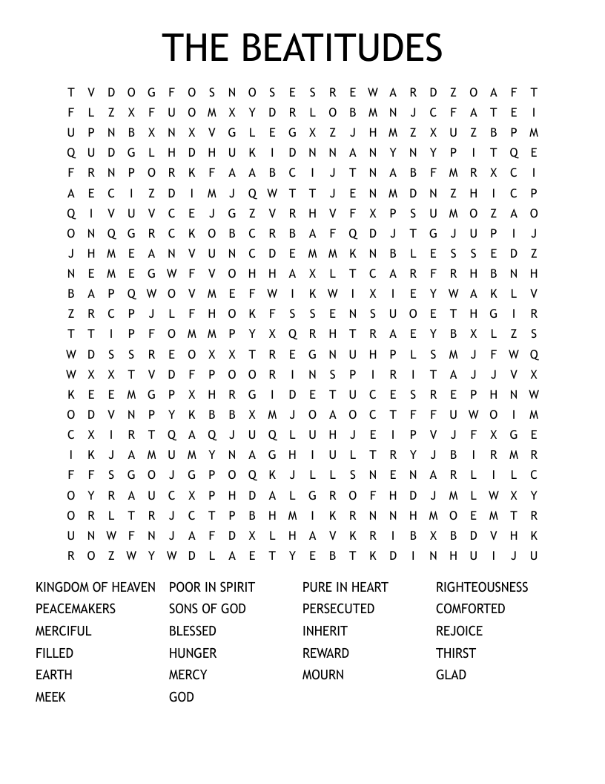

**The God of Little Things**

You are the God of little things,

You made the sheen of swallows’ wings.

You taught the skylarks how to fly,

High in the soft blue summer sky.

You are God, Lord over all,

And you know when the sparrows fall.

Your creatures Lord are in your care,

You even count my every hair.

You know my every thought and deed,

My every prayer, my every need.

For God who made the earth and sea,

Made everything including me.

Our God who put the stars in place,

And set the world to spin in space.

You listen when your children call,

Our God who cares when sparrows fall.

The great and mighty King of Kings

Is also God of little things.

Dear Lord, please give me

A few friends who understand me and remain my friends;

A work to do which has real value,

without which the world would be poorer;

A mind unafraid to travel, even though the trail be not blazed;

An understanding heart;

A sense of humour;

Time for quiet, silent meditation;

A feeling of the presence of God;

The patience to wait for the coming of these things, with the wisdom to recognize them when they come.

Amen.

**Prayer Pages**

**IN YOUR PRAYERS**  
If you know of someone who would appreciate being on our prayer list, please ensure you have the person's permission before passing their name to Michelle.

Please pray for Ron Gould, Win De La Mare, Karen Harrison,

Rachel Meinke, Caroline Treharne, Joyce Baudains,

Margaret Boden-Heaume, Bob Cartmell,

Wilfred (Debbie and Peter’s grandson), Rev John Luff and his wife Carole,

Howard Ellis (Sandra’s son), Debbie Hobbs,

Colleen Ogier and Debbie Dorey

**Bailiwick of Guernsey Churches Prayer Cycle for 2025**

Apr 06 Sark : Parish church of St Peter / Sark Methodist Church

***Apr 13 PALM SUNDAY***

***Apr 18 GOOD FRIDAY***

***Apr 20 EASTER DAY***

Apr 27 Parish church of Set Marguerite de la Forest & Forest United Methodist church

## FACTOR 7

**Please pray wherever you are: at home, work, in your car or shower, pray for**

7 minutes at 7am and/or 7pm

FOCUS THIS MONTH

As we continue our journey through Lent, pray for situations where life and growth are hard to find (e.g. church, world, locally).  Pray for grace and new life and give thanks for the life-transforming power of Jesus Christ!

Praise God that Jesus is alive!  Pray for those who find this foolish to believe, and those who doubt.  May God bring hope and peace to those experiencing tough and challenging times.



On a calm, warm spring morning at Saints Bay it reinforces the words of the prayer:  
‘And the peace of God, which surpasses all understanding, will guard your hearts and minds in Christ Jesus.’

**Preaching & Duty Stewart Schedule**

God & Marmalade is at 8.45am

|  |  |  |
| --- | --- | --- |
| **Date** | Preacher | Steward |
| **April 6th** | Victor Lane | Carole |
| **April 13th** | Jacky Cottrell | Nev |
| **April 17th Maundy Thursday** | *At Les Adams* | N/A |
| **April 18th**  **Good Friday** | **10.30am** ‘Sitting at the Cross’ | Sarah |
| **April 20th**  **Easter Day** | **8am** at Petit Bot  Jacky Cottrell (HC) | Beth |
| **April 27th** | Jacky Cottrell | Rosemary |

**Evening Service**

|  |  |  |
| --- | --- | --- |
| **Date** | **Preacher** | **Steward** |
| **April 13th** | **Victor Lane** | **Beth** |
| **April 20th** | **Jacky Cottrell (HC)** | **Nev** |
| **April 27th** | **Beth & Brian** | **Pam** |

**G & M Breakfast Rota**

|  |  |  |
| --- | --- | --- |
| **Date** | Breakfast | Setting up |
| **April 6th** | Sandra/Ian Jenny | Steve/Jan |
| **April 13th** | Debbie/Rosemary | David |
| **April 17th Maundy Thursday** | N/A | N/A |
| **April 18th Good Friday** | N/A | N/A |
| **April 20th Easter Day** | Carole/Nev | Leon |
| **April 27th** | Sarah | Steve/Jan |

Welcome Steward Rota

|  |  |  |
| --- | --- | --- |
| **Date** | AM | PM |
| **April 6th** | Andrea | Beth |
| **April 13th** | Sarah K | Brian |
| **April 17th Maundy Thursday** | N/A | N/A |
| **April 18th Good Friday** | Sandra | N/A |
| **April 20th Easter Day** | Brian | Sarah P |
| **April 27th** | Andrea | Brian |

**Flower Rota**

|  |  |
| --- | --- |
| **Date** |  |
| **6th April** | **Debbie Hobbs** |
| **13th April** | **Win de la Mare** |
| **20th April** | **Jenny Falla (Easter)** |
| **27th April** | **Sarah Keeley** |

**With grateful thanks to all who give their time to the service of the church**

**☼**

Notices/articles for next month let Michelle know by **Friday 23rd April**

Tel no: 01481 266019/07781 166019

email: [mgilson_gsy@hotmail.com](mailto:mgilson_gsy@hotmail.com)

**More wisdom out of the mouths of babes -**    
 A Sunday School teacher asked her class  
“If I sold my house and my car and all my possessions and gave the money to the church would I get into heaven?”  
“No Miss.”  
“If I cleaned the church from top to bottom, and did all the gardening outside it, would I get into heaven then?”  
“No Miss!”  
“Well then,” she continued, “how can I get into heaven?”  
A lad at the back shouted “You’ve gotta be dead Miss!”

**The minister got some new false teeth. His first sermon took only 4 minutes. A week later his next sermon took 7 minutes as he was having difficulties with his teeth. The following week his sermon went on for an hour. When asked why it was so long, he said that he had put his wife’s teeth in by mistake and she never stops talking!**

